Gracie Richards
CS 5100 Final Project
Introduction
Tetris has been shown to be an NP-complete problem, making it a great benchmark for evaluating artificial intelligence methods. A wide variety of different methods have been used to attempt solving the game. Nandini et al. used a combination of genetic algorithms, Q learning/deep Q learning, and greedily selecting the simulated move with the highest value for their scoring function.¹ Jacob Schrum, in his paper, developed neural networks, using a genetic algorithm to help evolve them.² He compared the performance of fully connected and convolutional neural networks (CNNs), two different coordinate geometries, and three different architectures (specifically the width and depth of the neural network). CNNs with not too large of a depth performed the best. Liu et al. tested several deep reinforcement learning algorithms (see methods section for further discussion of this paper).³
Schrum used low level features, which means using the raw pixel input or the grid of the game in binary as input to the algorithm.² Nandini et al. used high level features: number of lines completed with the current piece, number of holes, bumpiness (height difference between adjacent columns), maximum height, well depth, and height differential.¹ A linear combination was made of these features and the weights trained on. As a result, the original board has been converted into more useful features. Liu et al. uses number of holes in each column and height of each column as features.³
I had ideas for high level features, and implemented extracting them. However, I did not have time to incorporate them, and instead focused on using low level features.

Methods
I started by learning about the gym-tetris package, an OpenAI Gym environment for the NES version of Tetris.⁴ Since it was written for the deprecated version of Gymnasium, Gym, this software is not compatible with modern Gymnasium. My first goal was to figure out how to get the AI agent to play Tetris, without any strategy for now. By the first progress report, I had written code to convert the raw pixel data into a 20 by 10 matrix of the board state and started coming up with solutions for how to time when the agent should input its actions. Unknowingly I had stumbled upon the biggest and most time-consuming problem of this project: move timing.
I immediately noticed that the agent could move the piece every single frame if you let it, so I limited it to move at the rate the piece moves from gravity. However, it did not make sense to make multiple moves as the piece was falling; the agent should decide a single direction to move in and a limited number of rotations, and then execute them, one time per new piece. Detecting when the game had moved on to a new piece was a challenge in itself. In the end, I was only able to find a good solution for this once I had found a way to isolate the squares that were currently changing color on the board. After all this, it turned out that pressing the left or right button multiple times failed to move a piece multiple times. I tried implementing an action queue to space the inputs out to once per loop instead, but this did not fix the issue. Only when I multiplied the number of left/right presses by 10 did it start working (but I still did not know exactly how many columns the piece actually moved in game). Again, it was not until my program could detect the currently changing squares that I built a better control system, where for each frame, if the piece is not in the desired column or rotation, the agent tries to correct it with a single movement in the right direction. Once it has the right position and orientation, the agent “holds” the down button until the next piece spawn, causing the piece to fall every 2 frames instead of every 48 frames. Without this speedup, it would be untrainable.
These challenges show that gym-tetris is not a great interface for building an AI agent. I should not have stuck so rigidly to NES Tetris (meaning the version of Tetris that came out in 1989). I thought that knowing the version I had would help; for example, when my outputs said every move was earning a few points, I knew the specific rule that explained where those points came from and knew that there was not a bug in my code. But it would have been better if I had found a different package where every input results in an action and it is also the intended action, parts of the state like the board and when a new piece appears are given to you, and it does not run in human time so that training is orders of magnitude faster. Without these obstacles, I am confident I could have accomplished much more. Unfortunately at every point I could not foresee all of the other problems and I always assumed I was very close to having everything work.
In terms of which AI approach to use for this problem, my first plan was to use a greedy approach, where at each turn the agent would place the piece in the deepest hole currently on the board. This had one major issue, however, which is that it glosses over how one would place a piece into a hole. You could approximately move the piece to the right column (approximately, because a piece is usually not one column wide), but which orientation should the piece be in? Ideally the part pointing down should be long enough that it fills the hole and does not leave a gap (Figure 1b), but not be too long where it introduces a gap in other columns (Figure 1a).
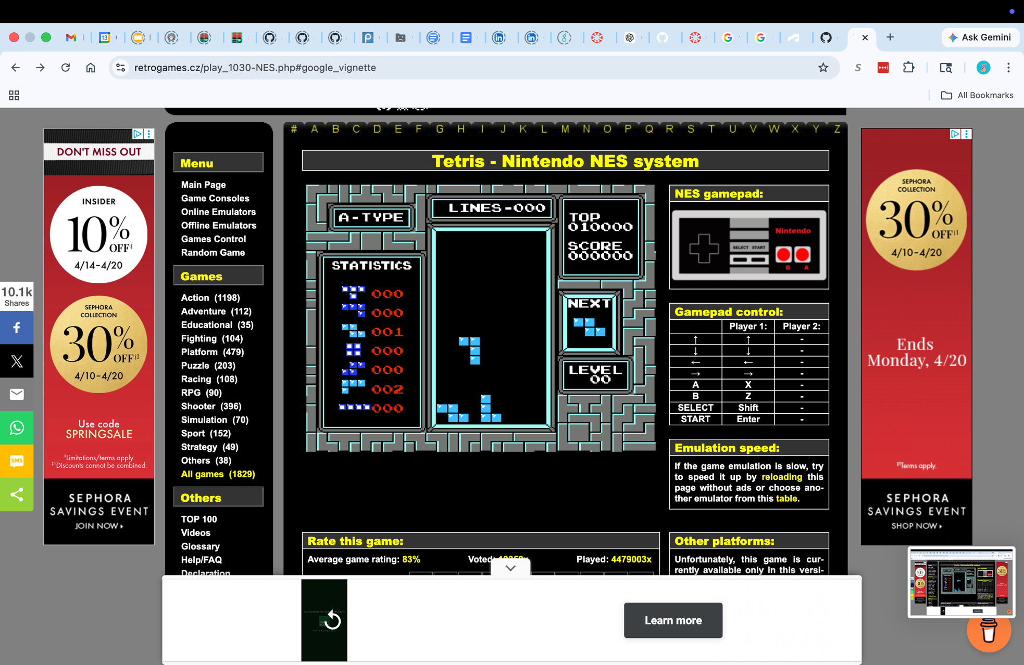
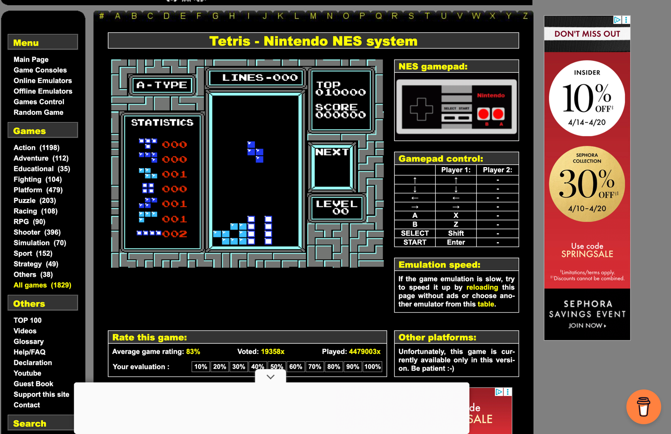
a b

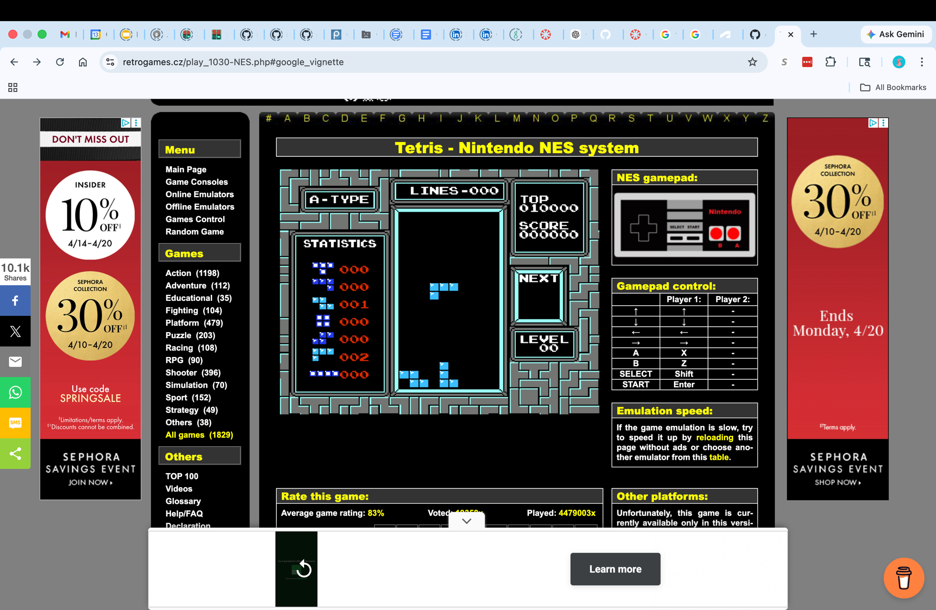
c

Figure 1. Example moves in NES Tetris, in the process of falling to the ground at which point the move will be complete. When move a is complete, there will be one unfilled square under the left overhang of the active piece. The piece in b is not long enough, only filling one square in the four square hole. c illustrates another major consideration for designing an agent—considering the columns adjacent to the hole and the shape of the piece as a whole. In this case the column to the right blocks the piece from reaching the hole.
This seemed to indicate that a machine learning method that can make decisions based on the whole board and piece shape was needed. Q learning was an option that fit, since it trains on state-action pairs. For the state I used the board, represented as a list of column heights, plus the type of the current piece. The action consisted of the column to drop in (specifically the column the leftmost part of the piece should be in) and the orientation of the piece. I knew that neural networks would have also been a good fit, since they can handle more data (for example the whole board instead of just the column heights) and learn patterns, instead of relying on the exact states it has seen before. Deep Q learning would also probably perform well, due to their suitability for Atari games, and as we have seen, both CNNs and deep Q learning have been used in the field of Tetris AI agents. However, I could not attempt this with the limited time I had after getting move timing to finally work. The results I have are for basic Q learning with an epsilon-greedy strategy and a dynamic learning rate based on the number of previous updates. The Q table is implemented as a dictionary of (state, action) tuple keys mapped to Q values. The rewards are calculated as follows: if lines were cleared, it is equal to the number of points earned in game. Else, reward = points – ( (the change in the max height) * max_height/2).
My results consist of log entries for each time the agent scored points. At this point, it is not clear if the agent is doing better than random chance, so my goal is simply to see if the agent is scoring points more often as training goes on. I will measure this by plotting number of points earned per episode.

Results
Training ~14,000 episodes took a day. This means each episode requires 6.171 seconds to run, and this is even after implementing the speedup (holding down). This is unfeasible as a way to train a machine learning algorithm.
As seen on the graph on the next page, points are not increasing over time, nor is the agent scoring points more often over time. The results near episode 14,000 look the same as the results from the first few episodes, which is that single line clears are happening completely by chance. Since a single line clear is worth 40 points and a double line clear is worth 100 points, we can see that there was only one double line clear, which occurred randomly, and all other data points must be single line clears. The variation among these points is due to the NES rule I mentioned earlier that can earn you a small amount of points; they can be ignored. There were 198 instances of earning points total over 14,094 episodes, meaning the agent is only scoring points at all every 71 episodes on average. This further supports the fact that this agent has not learned anything and is still acting randomly.

Conclusion
The test run of my basic Q learning approach and its results confirm that it is impossible to solve Tetris using an algorithm like Q learning alone, especially in a non-simplified Tetris environment. No learning happened, and it is not a matter of training time—there are too many states, too few ways to drop a piece in a helpful way, and even fewer instances where the game rewards you, for this method to work. The problem of solving Tetris is a little like image processing in a way—figuring out how pieces fit on one side of the board should teach you what to do in the same situation on the other side of the board, or in a different row, which is probably why convolutional neural networks have been successful for Tetris in the literature.
There are four results for “gym-tetris (AI or machine learning)” on Google Scholar, as opposed to the 9330 results for “tetris (AI or machine learning)”. Two of them were not referring to the same gym-tetris that I am using, one was on building a replacement for gym-tetris with a 53-fold speedup,⁵ while the last one uses a simplified Tetris environment similar to previous research to test their model on, but then evaluates several advanced reinforcement learning algorithms in gym-tetris.³ Focusing on the last paper, first they had to “hack the Rom of the NES Tetris” to change the speed of the game as it was “unacceptably slow”. Their results were that none of the agents were able to play Tetris after several days of training, and in testing sessions not a single line was cleared. They mention the difficulty of having a reward that is non-sparse enough for an agent to learn line clearing strategies, and that “random explorations [are] unlikely to clear the lines in game play”.³
Still, most papers use simpler Tetris environments than NES, if not toy environments. This means successful AIs and their strategies might not be transferable to a real game of Tetris. For example with NES, a four line clear is worth 30 times as many points as a one line clear.⁶ This would have a significant impact on strategy, as one that is smart enough to plan four line clears would have a far superior strategy compared to one that does not. And ironically, the columns have much higher heights when setting these clears up, which would never happen in an AI game, and especially not if it was not trained with these rules.
Switching to high level features may improve performance, depending on the approach. Low level features may be perfectly fine for a CNN, which are designed to learn and apply patterns from raw data. Other algorithms, like deep Q learning, would probably benefit a lot from having the parts that are important for Tetris strategy extracted out.
Liu et al. then states that “To our best knowledge, there is no non-population based reinforcement learning agent that is able to play the original NES Tetris without action space searching, state enumeration, or explicit step-wise reward shaping.”³ Interestingly, they state that the large number of ways for a piece to reach a target position is a limitation for solving Tetris, but this is not a problem in my implementation, where each target position has a unique column + rotation pair. However, I believe the intricacies of NES Tetris still present major challenges.
A strength of my implementation is that I have learned about these intricacies and created a model that is able to place pieces in the positions that it specifies, even in this unintuitive, nondeterministic environment. It is able to monitor the state of the game, including transitions like when a new piece appears. I have accomplished some of the most important parts of an AI model: understanding the environment and performing an action according to the environment’s rules (and in this case making a plan to accomplish each action, as it translates moves into individual button presses). I found a simple way to uniquely represent piece orientations, so the orientation of the current piece and orientations in a lookup table can be compared. As a result, it would now be easy to substitute in another artificial intelligence algorithm, now that we have this intermediary software between the NES “Real-world Environment”³ and agents that decide on actions frame by frame.

Works Cited
- ‌C. Nandini, S. S, K. Biswas, P. Dar, N. Hassan, and R. A. Khan, “Reinforcement Learning for Tetris Game with Genetic Algorithms,” 2025 IEEE 7th International Conference on Computing, Communication and Automation (ICCCA), pp. 1–6, Nov. 2025, doi: https://doi.org/10.1109/iccca66364.2025.11325441.
- J. Schrum, “Evolving indirectly encoded convolutional neural networks to play tetris with low-level features,” Proceedings of the Genetic and Evolutionary Computation Conference, Jul. 2018, doi: https://doi.org/10.1145/3205455.3205459.‌
- H. Liu and L. Liu, “Learn to Play Tetris with Deep Reinforcement Learning,” openreview.net, Dec. 2020, Available: https://openreview.net/forum?id=8TLyqLGQ7Tg
- Christian Kauten, “GitHub - Kautenja/gym-tetris: An OpenAI Gym interface to Tetris on the NES.,” GitHub, 2019. https://github.com/Kautenja/gym-tetris/tree/master
- X. Chen et al., “Bitboard version of Tetris AI,” arXiv.org, 2026. https://arxiv.org/abs/2603.26765 (accessed Apr. 13, 2026).
- “Tetris (NES video game),” Wikipedia, May 01, 2022. https://en.wikipedia.org/wiki/Tetris_(NES_video_game)

